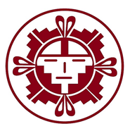

**Association on American Indian Affairs**

Protecting Sovereignty ◦ Preserving Culture

Educating Youth ◦ Building Capacity

Since 1922

Press Contact: Eldred D. Lesansee

Eldred.aaia@indian-affairs.org

**BUYERS SHOULD INVEST IN CONTEMPORARY AMERICAN INDIAN ART INSTEAD OF AMERICAN INDIAN ANTIQUITIES**

WASHINGTON, D.C., December 6, 2018, 10:00 a.m. E.S.T. – The **Association on American Indian Affairs**, together with the **Affiliated Tribes of Northwest Indians**; **Association of Tribal Archives, Libraries, and Museums**; **Bernstein & Associates**; **Delaware Tribe of Indians**; **First Peoples Fund**; **Gray & Pape Heritage Management**; **International Indian Treaty Council**; **Indigenous Peoples Law and Policy Program at the University of Arizona James E. Rogers College of Law**; **Institute of American Indian Arts**; **Klahoose First Nation**; **National Congress of American Indians**; **Robert S. Peabody Institute of Archaeology**; **Southwestern Association for Indian Arts**; **Tonkawa Tribe**; **United Tribes of Michigan**; and the **White Earth Nation** urge collectors and auction-goers interested in purchasing American Indian “artifacts” and “antiquities” to exercise cautious due diligence. Rather, collectors interested in American Indian art should instead support contemporary American Indian artists and their creations made for the art market.

There is a long history of looting and stealing American Indian burials and important American Indian cultural and sacred patrimony. These items often end up in private collections and ultimately auction houses and institutions all over the world. In many cases possession of these items outside their communities of origin contravene Tribal laws, and in some cases federal and state laws. For instance, federal law provides that certain types of objects are inalienable from their Tribal Nations as they are held as national or religious patrimony that have an “ongoing historical, traditional, or cultural importance central” to the Tribe.

Auctioneers, consignors, and dealers have professional and ethical responsibilities to deal honestly with the public and validate the ownership of any item for sale. Yet, it is currently not standard practice to reach out to potentially affiliated Tribal Nations to determine whether Native American Ancestral remains, burial belongings, and objects of sacred and cultural patrimony are rightfully in the market. For Tribal Nations, these communally nation-held items are not “art” and should not be displayed or sold, but rather are living and breathing entities that are essential to the continuation of diverse American Indian cultures, traditions and religious practices today.

Buyers and collectors interested in Tribal antiquities and artifacts should do their own careful due diligence and consideration as to whether Ancestors and burial belongings, and cultural and sacred patrimony are a proper investment. Perceptions on collecting items of Tribal Cultural Heritage are changing quickly, along with laws that seek to protect them. Finally, and as stated above, **buyers and collectors should focus their investment on contemporary American Indian artists whose stories and creations are accessible and created to share.**

The seventeen following organizations and Tribes have partnered with the Association on American Indian Affairs to release this statement in unity, representing indigenous peoples, academia and experts all over North America:

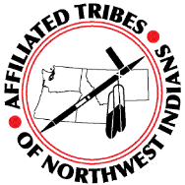

In 1953, Tribal leaders in the Pacific Northwest organized as the Affiliated Tribes of Northwest Indians (ATNI) and dedicated their efforts to supporting tribal sovereignty and self-determination. Today, ATNI is a nonprofit organization representing nearly 50 Tribal governments from the greater Northwest including Oregon, Idaho, Washington, Alaska, California and Montana. It is the intent of ATNI to represent and advocate for the interests of its member Tribes.

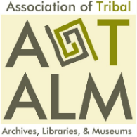The Association of Tribal Archives, Libraries & Museums provides culturally relevant training for tribal archives, libraries, and museums, encourages collaboration among tribal and non-tribal cultural institutions, and articulates contemporary issues related to developing and sustaining the cultural sovereignty of Native Nations.



Bernstein & Associates has over 30 years’ experience successfully working collaboratively with Indian Tribes, Alaska Native villages, Native Hawaiian organizations, museums, universities and colleges, government agencies, and lineal descendants to facilitate repatriation of thousands of ancestors and cultural items. We provide NAGPRA training, strategic planning, consultation planning, document development, and consultation facilitation to support repatriation efforts.

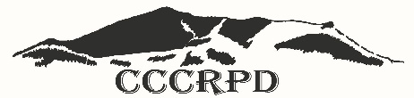

The Rocky Boy’s Indian Reservation is home to the Chippewa Cree Tribe and is located in rural north-central Montana. The Chippewa Cree Tribe has designated the Chippewa Cree Cultural Resource Preservation Department (CCCRPD) by Tribal resolution with the responsibility of preserving and protecting the cultural, spiritual, medicinal, and historical properties deemed significant and unique to the Chippewa Cree people.

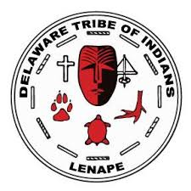

The Delaware Tribe of Indians is the largest of the Lenape descendant Tribes located in northeastern Oklahoma and Kansas.  Often referred to by other Tribes as the “Grandfathers,” the Lenape were the original people of the mid-Atlantic region; indigenous to the northern reaches of the Chesapeake Bay, through all of New Jersey, Manhattan and southern New York, and all of Pennsylvania east of the Alleghenies.

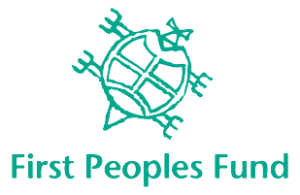First Peoples Fund's mission is to honor and support the Collective Spirit of Native artists and culture bearers. Collective Spirit is that which moves each one of us to stand up and make a difference, to pass on ancestral knowledge or simply extend a hand of generosity. Through grant making, culturally-rooted programming, training and technical assistance, First Peoples Fund is committed to uplifting Native artists, and the networks that support them, all across the United States.

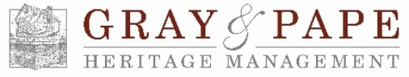

Gray & Pape Heritage Management is a small-business with over 30 years’ experience specializing in the delivery of cultural heritage management services to public and private clients. Gray & Pape works with project stakeholders to facilitate the consultation process so that culturally appropriate, respectful decisions occur in a way that is satisfactory to Indian tribal nations and sensitive to project requirements and schedules.

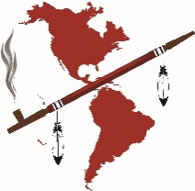The International Indian Treaty Council (IITC) is an organization of Indigenous Peoples working for self-determination and the recognition and protection of human rights, Treaties, traditional cultures and sacred lands. IITC was founded in 1974 on the Standing Rock Reservation in South Dakota to serve as an international voice and advocate for Indigenous Peoples. In 1977 IITC became the first Indigenous organization to receive Consultative Status with the United Nations Economic and Social Council (ECOSOC) and in 2011to be upgraded to “General Consultative Status.”

Indigenous Peoples Law and Policy (IPLP) Program and the University of Arizona James E. Rogers College of Law instills a strong understanding of the legal foundations of federal Indian law, tribal self-determination, and the trust responsibility, informed by developing norms of contemporary international law respecting indigenous peoples’ human rights. IPLP equips students with the critical thinking skills and lawyering tools needed to develop innovative and effective legal strategies and policy initiatives to promote and advance the rights of indigenous communities across Indian Country and throughout the world.

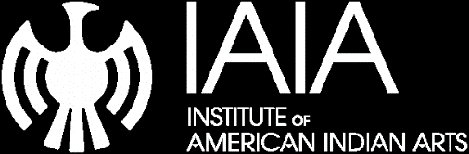

At the Institute of American Indian Arts, the spirit and vision of Native American and Alaska Native people is a first priority. Founded on October 1, 1962, the Institute of American Indian Arts offers academic excellence to both Native and non-Native populations. Our goal is empowerment through education, economic self-sufficiency and expression and enhancement of artistic and cultural traditions.



The Klahoose First Nation is a First Nations band government whose traditional territories are located on Cortes Island at the northern end of the Strait of Georgia, and surrounding Toba Inlet, British Columbia. We, the Klahoose people, are the original caretakers of the land. We live by our values which are based on our culture, tradition, unity, and equality. Social well-being, good health and education are essential for a safe, prosperous community. Through our vision, the Klahoose community ensures a future for our children and the generations that follow.

Founded in 1944, the National Congress of American Indians is the largest and most representative American Indian and Alaska Native organization in the country. NCAI advocates on behalf of tribal governments and communities, promoting strong tribal-federal government-to-government policies, and promoting a better understanding among the general public regarding American Indian and Alaska Native governments, people and rights.

Robert S. Peabody founded The Robert S. Peabody Institute of Archaeology in 1901 to introduce the students of Phillips Academy to the world of archaeology, to promote archaeological research, and to provide a place for students to gather. Peabody Institute employs collaborative learning to actively engage students, teachers, scientists, and Native Americans with the institute’s significant archaeology and anthropology collections, while encouraging and enlivening cultural discourse on race and gender.

The Southwestern Association for Indian Arts (SWAIA) is a non-profit organization that promotes Native art and artists by bringing Native arts to the world through inspiring artistic excellence, fostering education, and creating meaningful partnerships. SWAIA organizes the Santa Fe Indian Market every year.

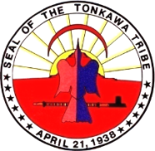

The Tonkawa Tribe is located in Kay County, in Northern Oklahoma. The Tonkawa Tribe honors those who lie in their eternal rest. The Tonkawa people are a rare breed that survived warfare, changing history and expansionist movements against their great nation. The Tonkawa Tribe works to protect, preserve and enhance culture and traditions now and for our future generations – *“Tic-kan-wa-tic.”*

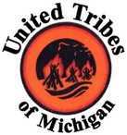

The United Tribes of Michigan is committed to join forces, advance, protect, preserve and enhance the mutual interests, treaty rights, sovereignty and cultural way of life of the sovereign tribes of Michigan throughout the next seven generations.

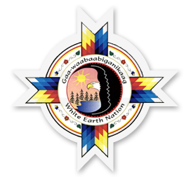

The White Earth Nation is Minnesota's largest reservation, encompassing 1,300 square miles and serving as the homeland for over 20,000 band members. The White Earth Nation are the Anishinaabe, which means “the original people.” The White Earth Reservation is located in Becker, Clearwater, and Mahnomen counties in north-central Minnesota. The White Earth Tribal Historic Preservation Department is committed to repatriation and to the ongoing protection and revitalization of cultural resources.