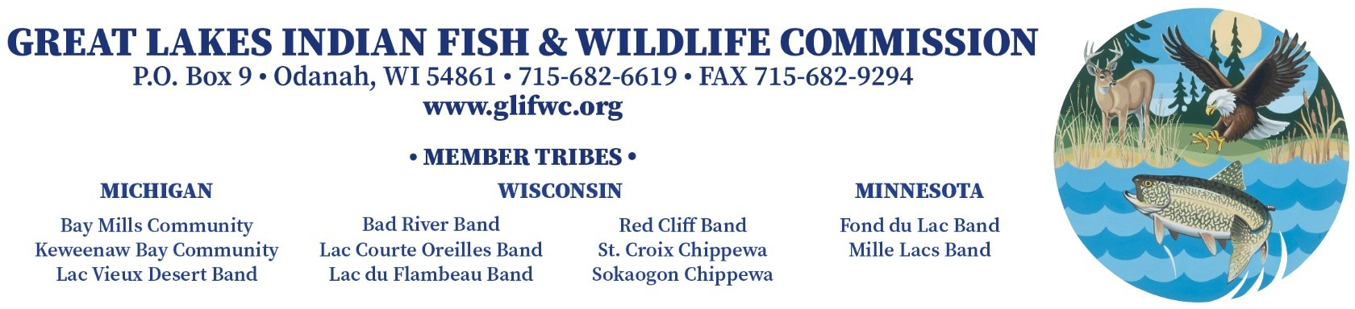

JOB ANNOUNCEMENT

TITLE: Comptroller, Division of Administration

LOCATION: Great Lakes Indian Fish and Wildlife Commission Odanah, Wisconsin

CLOSING DATE: December 6th, 2022

CLASSIFICATION: Permanent, Full-Time

SALARY : Salary Range: $79,167 - $92,362 (Dependent on Qualifications). Note: Position has been classified as 50% tax-exempt for qualified tribal members under Internal Revenue Code §7873 – Tax Exemption for Income Derived from Treaty Fishing Rights Related Activities. GLIFWC’s benefit package includes: 1) Federal Health Insurance (i.e., employer pays 87.5% of annual insurance premium); 2) vision and dental insurance (i.e., employer pays 75% of annual insurance premium); 3) retirement plan (i.e., employer provides a 6% contribution); 4) cafeteria plan; 5) disability insurance; 6) life insurance; 7) 14.5 paid holidays annually; 8) 12 paid vacation days annually; 9) 1 paid personal day annually; and 10) 12 paid medical leave days annually.

DUTIES AND RESPONSIBILITIES

The Comptroller is responsible for maintaining an adequate fiscal management system to ensure compliance with Commission funding contracts and grants and provide day-to-day supervision of all accounting staff. Primary duties include: supervising three senior accounting staff; ensure compliance with OMB Super Circulars and 638 contracting requirements; assist in the Commission’s annual budget process; prepare the Commission’s indirect cost proposal and administer the indirect cost system; supervise the Commission’s payroll system and approve payroll reports and tax forms; approve electronic requisitions and payment vouchers; and assist in contracting and preparing the Commission’s single audit. The position will perform the duties listed above in a manner consistent with the Commission policies and procedures and report to the Deputy Administrator.

QUALIFICATIONS

Applicants: preferred CPA or MS in Accounting or MBA in finance; minimum must possess a Bachelor’s degree in Accounting, Business Administration (i.e. with an accounting emphasis) with 5 years of relevant fund accounting experience. In addition, applicants are required to demonstrate:
- Proficiency in accounting software (Abilia MIP Fund Accounting preferred);
- Demonstrated skills in the ability to manage and supervise accounting staff;
- Strong numerical, budgeting and spreadsheet analytical skills;
- Ability to obtain, compile, summarize and integrate narrative information and quantitative data;
- Demonstrated experience in working with Single Audit requirements, GAAP, OMB Super-circular, and indirect cost proposal preparation, negotiation, and administration;
- Strong written and oral communication skills; and
- Must have a valid driver’s license and be insurable.
Preferred work or other relevant experience with Indian Tribes, non-profit organizations or governmental agencies that utilize fund accounting.
Indian preference will be applied consistent with GLIFWC policies and the federal Indian Self Determination and Education Assistance Act (PL 93-638)

APPLICATION PROCEDURE
Applicants must submit a completed GLIFWC application for employment (available at www.glifwc.org), letter of interest, resume, 3+ page writing sample and three professional references to: Keith Rolof, Deputy Administrator, Great Lakes Indian Fish & Wildlife Commission, P.O. Box 9, Odanah, WI 54861; OR email to: krolof@glifwc.org with subject line: Comptroller Job Application

