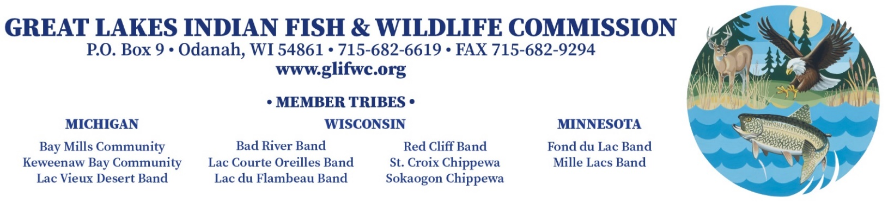
JOB ANNOUNCEMENT
Title: Human Resources Director
Department: Administration
Closing Date: December 16, 2022
Classification: Permanent, Full-Time
Salary: Starting Salary Range: $79,167 - $92,362 (Dependent on Qualifications). Note: Position has been classified as 50% tax exempt for qualified tribal members under Internal Revenue Code §7873 – Tax Exemption for Income Derived from Treaty Fishing Rights-Related Activities. GLIFWC’s benefit package includes: 1) Federal Health Insurance (i.e., employer pays 87.5% of annual insurance premium); 2) vision and dental insurance (i.e., employer pays 75% of annual insurance premium); 3) retirement plan (i.e., employer provides a 6% contribution); 4) cafeteria plan; 5) disability insurance; 6) life insurance; 7) 14.5 paid holidays annually; 8) 12 paid vacation days annually; 9) 1 paid personal day annually; and 10) 12 paid medical leave days annually.

DUTIES AND RESPONSIBILITIES
Under the supervision of the Executive Administrator, the Human Resources Director will plan organize, and direct all aspects of the human resource function, including employment, policy development, and employee relations.

The HR Director will work with the Executive Administrator and will oversee the revision and implementation of the Commission’s comprehensive personnel policies. In addition, the HR Director shall: 1) update and GLIFWC’s Grade/Step pay scale to ensure it is consistent given various job functions, responsibilities, skills and educational requirements, 2) assess budgetary impacts of any GLIFWC’s Grade/Step pay scale changes, and 3) ensure GLIFWC’s Grade/Step pay scale implemented in an equitable manner given job functions and responsibilities.

Other duties include: 1) providing training to GLIFWC staff in regard to the revised personnel policies, 2) preparing and standardizing job announcements and position descriptions, 3) assisting in staff recruitment (i.e., advertising, interviewing, evaluation and selection of employees), 4) developing a systematic employee orientation, 5) assisting supervisors in the interpretation and implementation of the Commission’s Personnel policies and ensuring compliance with disciplinary standards, 6) assisting in resolution of employee conflicts, 7) providing training and assistance to supervisors conducting annual staff performance evaluations, and 8) developing and implementing a systematic career developmental program to increase the number of tribal members GLIFWC hires and retains.

Qualifications
Applicants must possess: 1) MBA in Human Resource Management preferred; or 2) Bachelor of Administration in Business Administration – Human Resources and a minimum of five (5) years of related work experience which included performing human resources functions. In addition, applicants are required to demonstrate:
- Coursework including: 1) human resource management, 2) leading and working in teams, 3) personnel staffing and evaluation, 4) compensation theory and administration, 5) managing technological and organizational change, 6) negotiations, 7) labor-management relations; and 8) analytics and data decisions.
- Experience in employment law, compensation structures, organizational planning and development, employee relations, training, safety, and active affiliations with Human Resource professionals or organizations is preferred.
- Must have knowledge and understanding of employment law and be familiar with tribal, state, and federal regulations regarding employment.
- A high degree of skill in written and oral communications is required in addition to demonstrated abilities in working with others and leading teams.
- An ability to be self-motivated, work independently and effectively implement and manage projects.
- Must have a valid driver’s license and be insurable.
- Work or other relevant experience with Indian Tribes preferred.
- Indian preference will be applied consistent with GLIFWC policies and the federal Indian Self Determination and Education Assistance Act (P.L. 93-638)

Application Procedure
Applicants must submit a completed GLIFWC application for employment (available at www.glifwc.org), letter of interest, resume, 3+ page writing sample and three professional references to: Keith Rolof, Deputy Administrator, Great Lakes Indian Fish & Wildlife Commission, P.O. Box 9, Odanah, WI 54861; OR email to: krolof@glifwc.org with subject line: Human Resource Director Job Application

